Week 10

Q.1). Read a dataset and create different line and bar plots using Matplotlib.
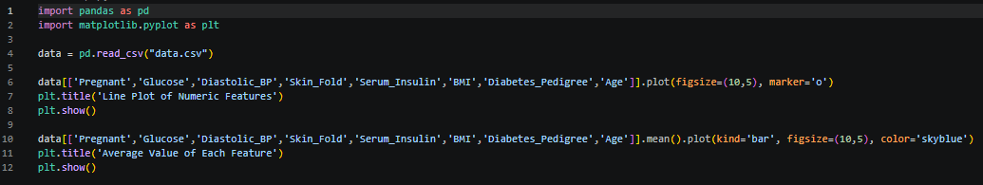
Output
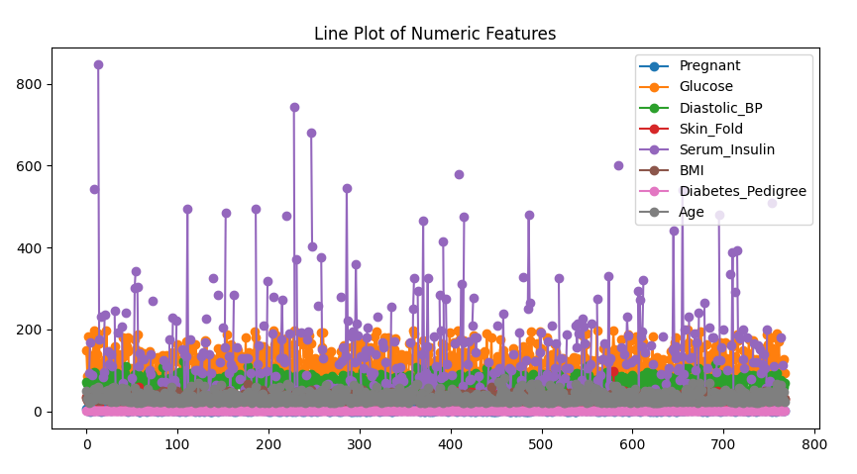
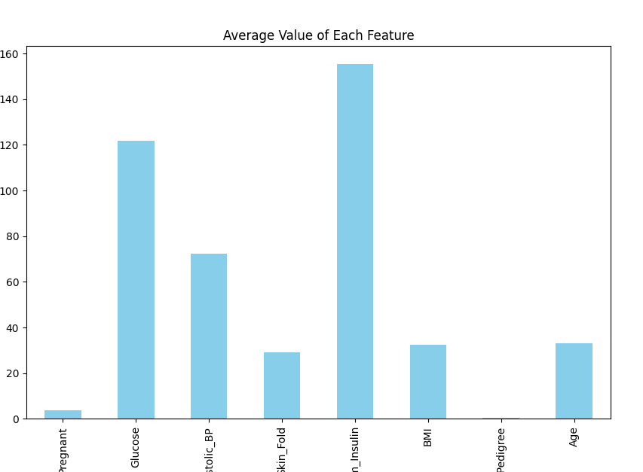

Q.2). Use the same dataset and plot histograms and boxplots using Seaborn.
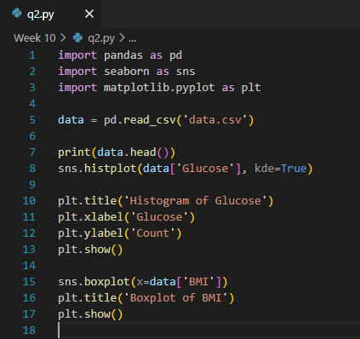
Output
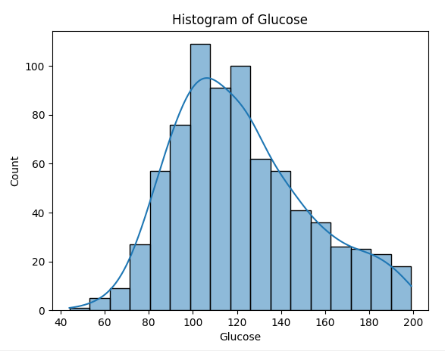
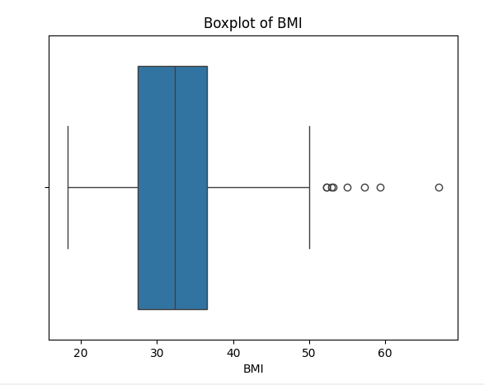
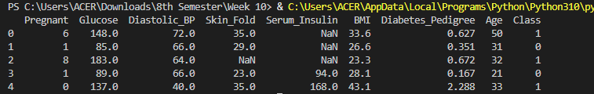
Q.3). Create scatter plots for feature relationships and generate a correlation heatmap
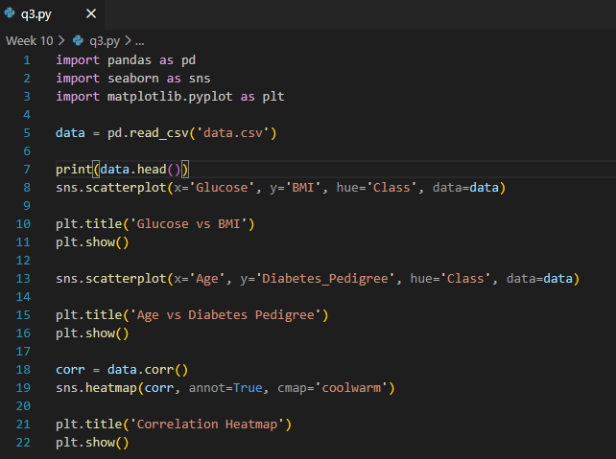
Output
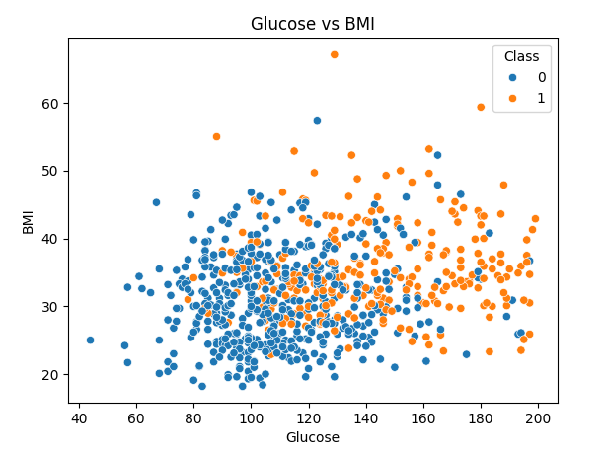
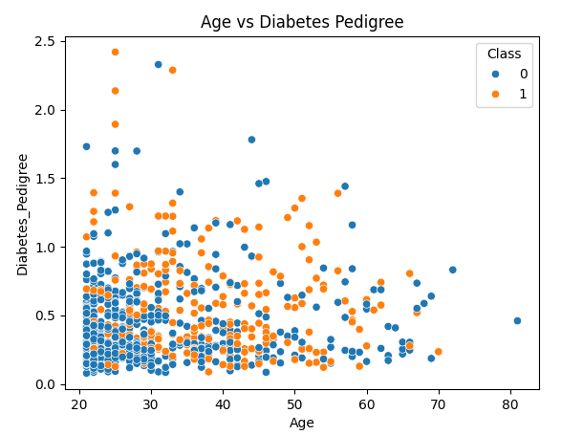
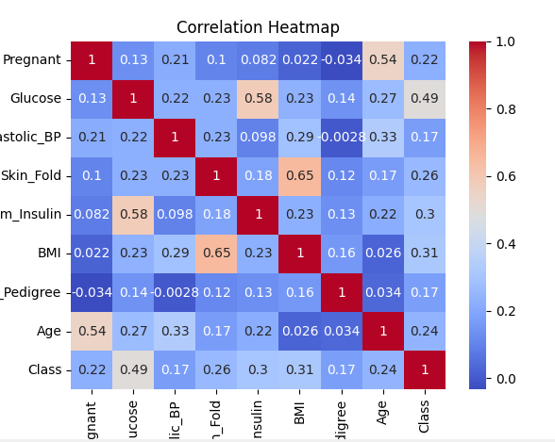
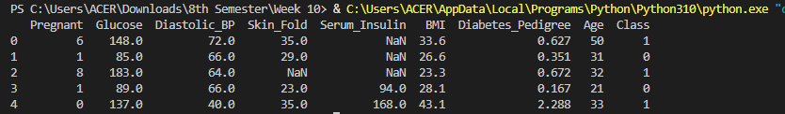

Problems based on HTML and JavaScript
Q.4). Develop a Web page with the following enhancements:
- A rollover effect, where an image changes if the user places the mouse over it.
- An animation that occurs in response to the user clicking on an image.
- A pull-down menu with each option linking to a specific page.
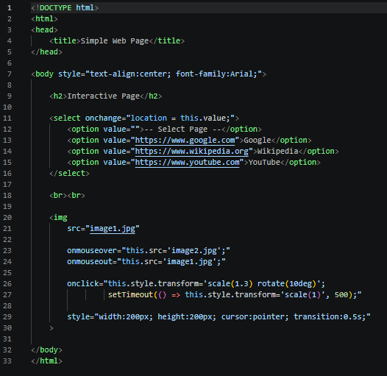
Output
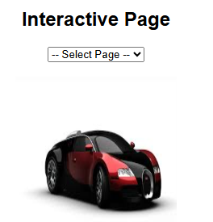
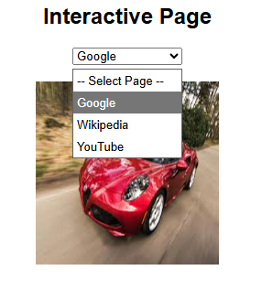

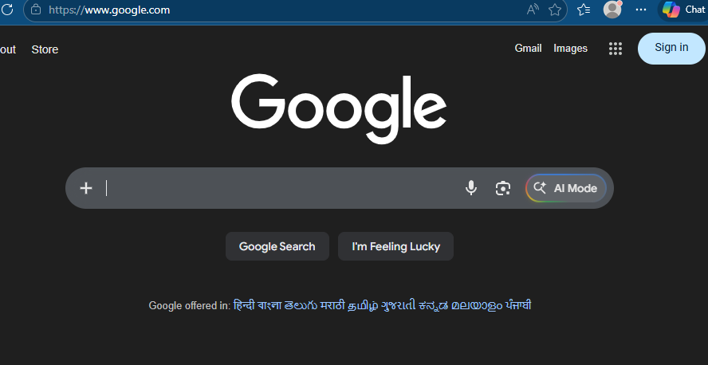

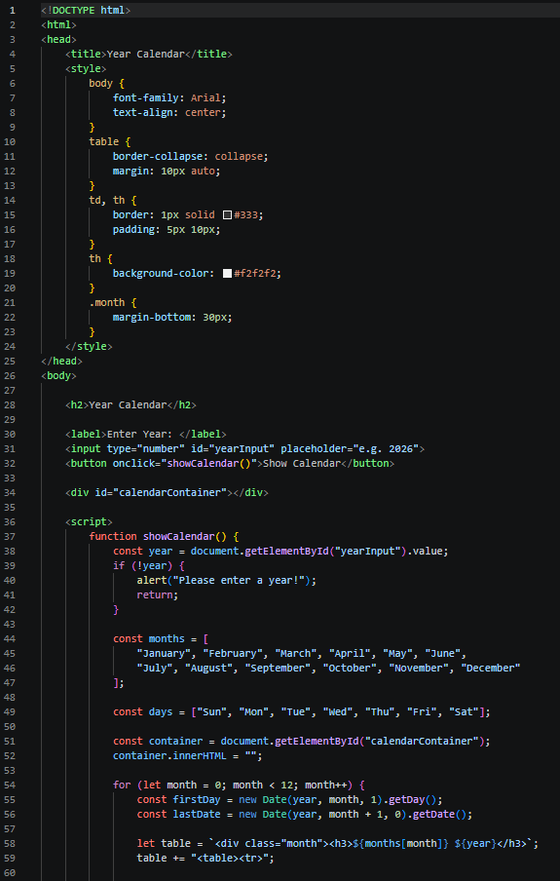
Q.5). Display the calendar using JAVA SCRIPT code by getting the year from the user.

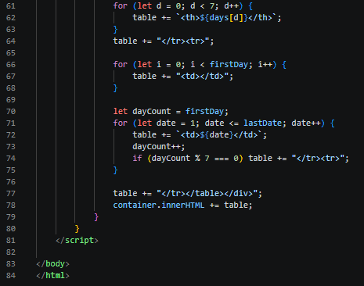

Output
